BLDC and PMSM Sensor less   
 Applications

Part I: BLDC Sensor less Application

1. Introduction

This lab provides a guide for how to run and control BLDC sensor less application with NXP Freedom development board FRDM-KV31F.

2. Hardware setup

The BLDC sensor less application runs on Freedom development platform FRDM-KV31F with default 24 Volt Linix Motor.

2.1. Motor Linix 45ZWN24-40

Motor Linix 45ZWN24-40 described in Table 1 is used by the BLDC Sensor less application.

Table 1. Motor Linix 45ZWN24-40 parameters

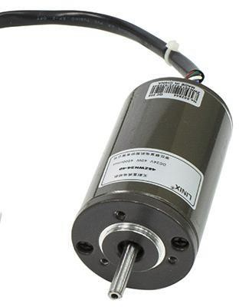

|  |  |  |  |
| --- | --- | --- | --- |
| Characteristic | Symbol | Value | Units |
| Rated Voltage | Vt | 24 | V |
| Rated Speed @ Vt |  | 4000 | RPM |
| Rated Torque | T | 0.0924 | Nm |
| Rated Power | P | 40 | W |
| Continuous Current | Ics | 2.34 | A |
| Number of Pole Pairs | pp | 2 | - |

The motor has two types of (cables) connectors.

One cable has 3 wires and is designated to power the motor.

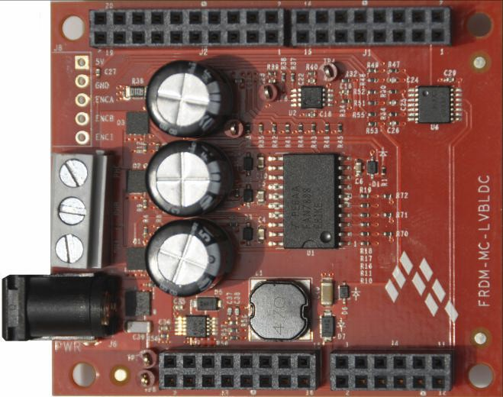

The second cable has 5 wires and is designated for Hall sensors signal sensing.

For BLDC sensor less application, the power input three wires cable are the only one   
needed.

2.2 Freedom System

To run the BLDC application using the NXP Freedom System, following Freedom boards are required:

• Kinetis KV31F Freedom board (FRDM- KV31F).

• Three-phase low voltage power Freedom shield (FRDM-MC-LVBLDC) with

included Linix motor.

2.2.1 FRDM-MC-LVBLDC

The FRDM-MC-LVBLDC low voltage evaluation board, in a shield form factor, effectively turns a Freedom development board platform into a complete motor control reference design, compatible with existing Freedom development   
platform FRDM-KV31F.

FRDM-MC-LVBLDC board does not require any hardware configuration or jumpers setting. It contains no jumpers.

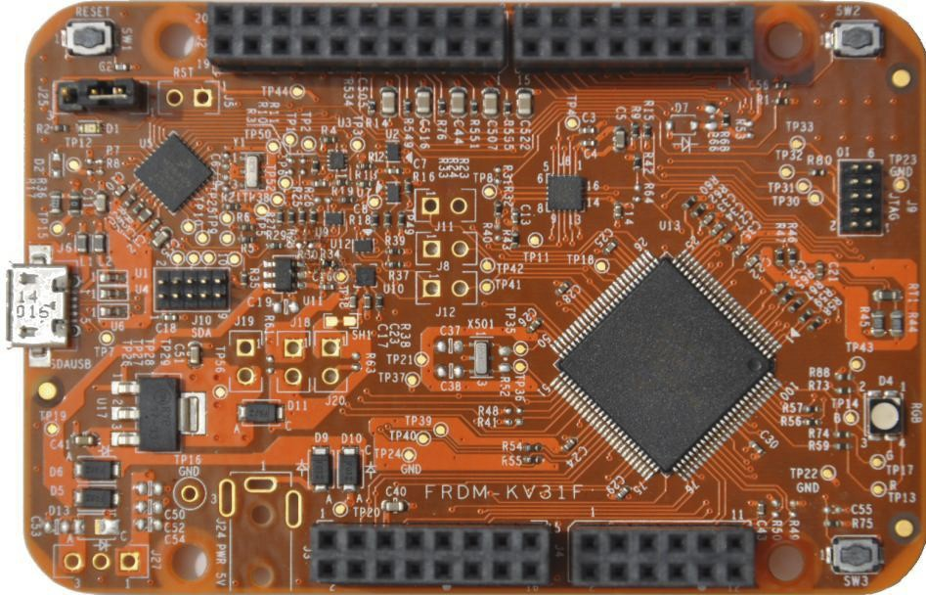

2.2.2 FRDM-KV31F

The FRDM-KV31F is a low-cost development tool for the Kinetis V series KV3x MCU family built on the ARM® Cortex®-M4 processor.

The FRDM-KV31F hardware is form-factor compatible with the Arduino™ R3 pin layout, providing a broad range of expansion board options, including FRDM-MC-  
LVPMSM and FRDM-MC-LVBLDC for permanent magnet synchronous motor and brushless DC motor control.

The FRDM-KV31F platform features OpenSDA, the Freescale open source

hardware embedded serial and debug adapter running an open-source bootloader.

This circuit offers several options for serial communication, flash programming, and run control debugging.

FRDM-KV31F board does not require any hardware configuration or jumpers setting. It contains no jumpers.

SW2

Freedom System Assembling

1. Connect the FRDM-MC-LVBLDC shield on top of FRDM-KV31F   
 board. There exists only one possible option.

2. Connect the BLDC motor three phase wires into the screw terminals on   
 the board.

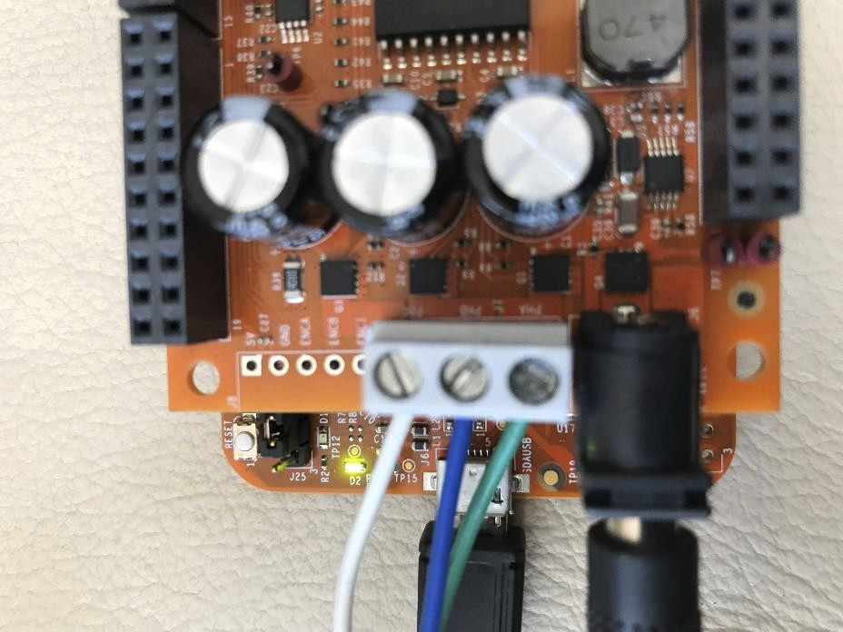

3. Plug in a USB cable from a USB host to the OpenSDA micro-USB   
 connector

4. Plug in a 12V DC power supply to the DC Power jack

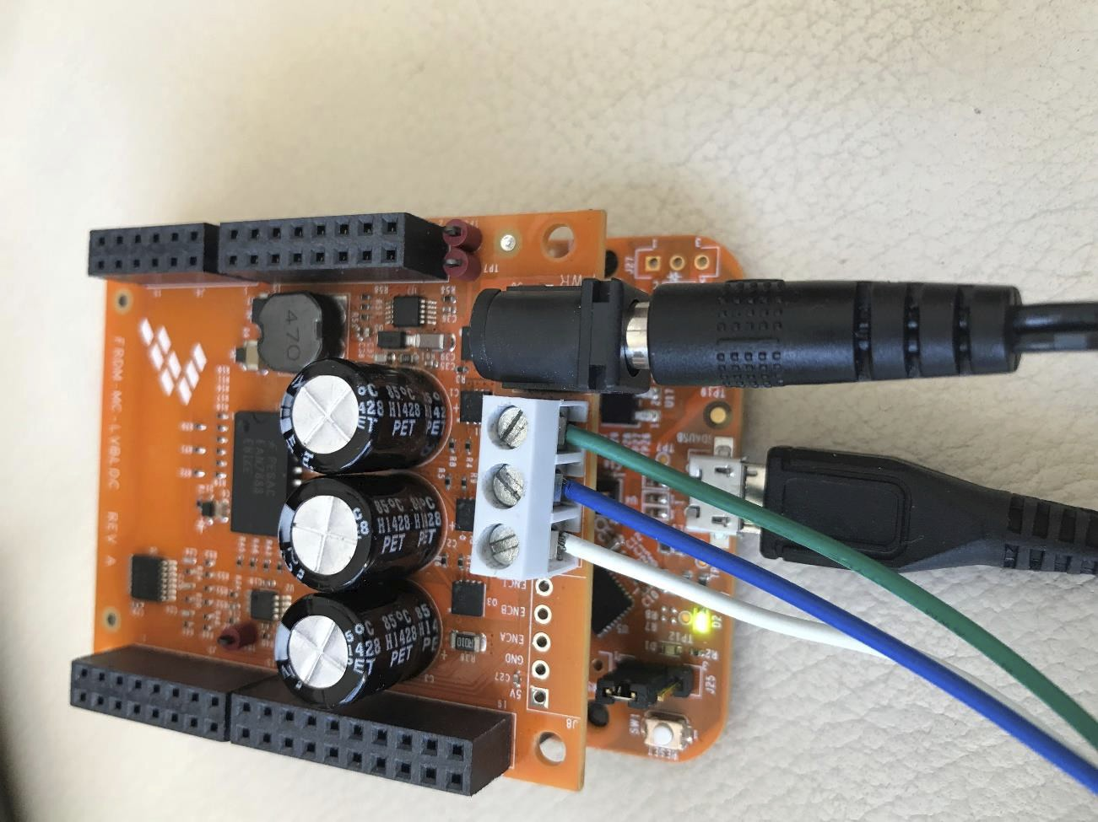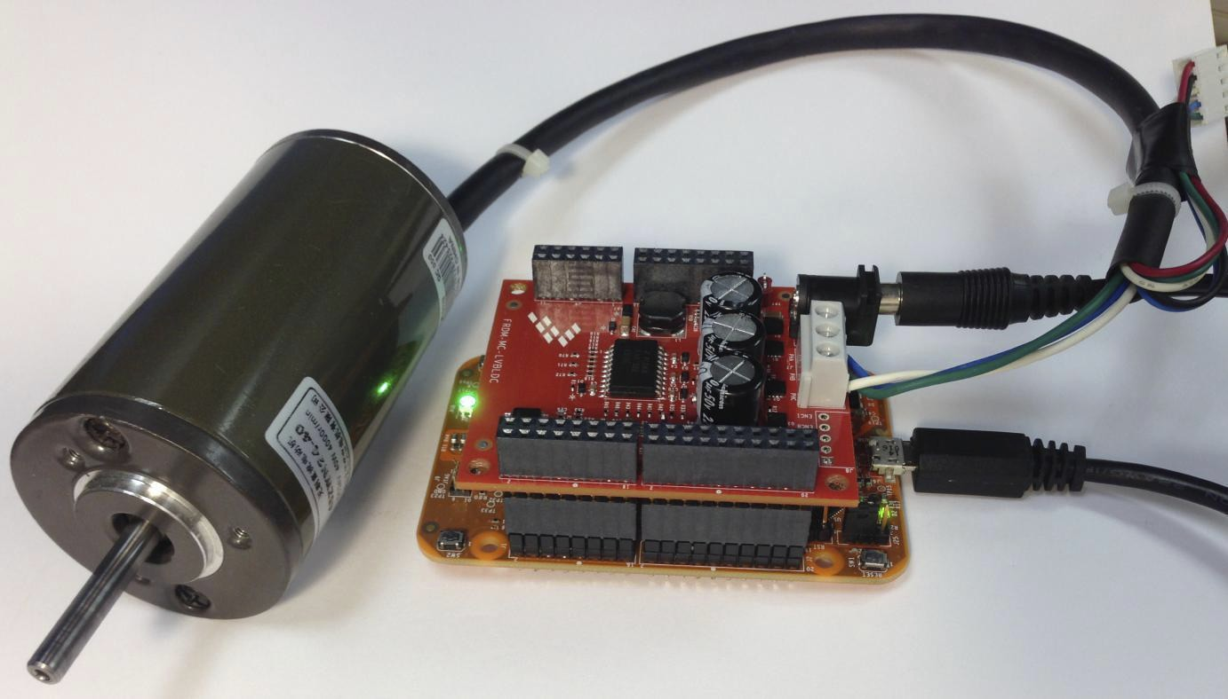

3. MCRSP_BLDC Package.

MCRSP_BLDC package includes source codes for development board. The package folder can be found at your course website.

4. Tools

Install the following software on your PC to run and control BLDC sensor less application.

1. [Kinetis Design Studio IDE v3.0 or higher](http://www.freescale.com/kds)

2. [FreeMASTER Run-Time Debugging Tool 2.0](http://www.freescale.com/freemaster)   
 (If you did not install it in the previous lab)

3. Install MCRSP_BLDC Package.

5. Building and debugging application using Kinetis   
 Design Studio (KDS) V. 3.

Kinetis Design Studio known as KDS is IDE tool.

KDS can be used for developing and testing applications with NXP MCUs.

KDS includes tools for compiling, linking, and debugging source code and support a wide range of debuggers such as PEMicro or Jlink and more.

1. Locate the “MCRSP_BLDC_V1.3” executable file at the course website and   
 install it. For example, the folder will be at C:\NXP\MCRSP_BLDC_V1.3.

2. Run KDS IDE

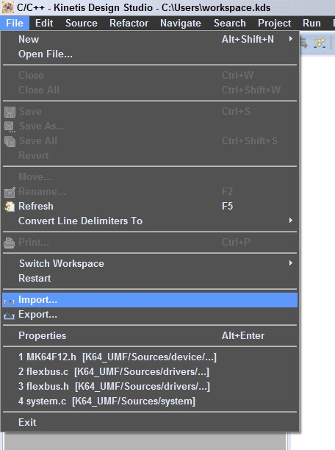

3. Select workspace: choose default or specify new one then click OK.

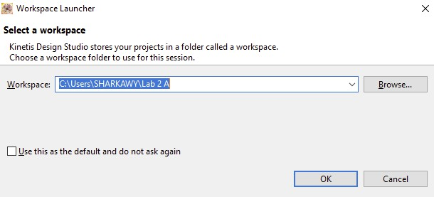

4. Click on “File” menu in left-top corner of the IDE then chose “Import” from   
 “File” list menu.

5. The “Import” window is opened. Locate “Existing Projects into Workspace” in   
 “General” folder then clicks the “Next” button.

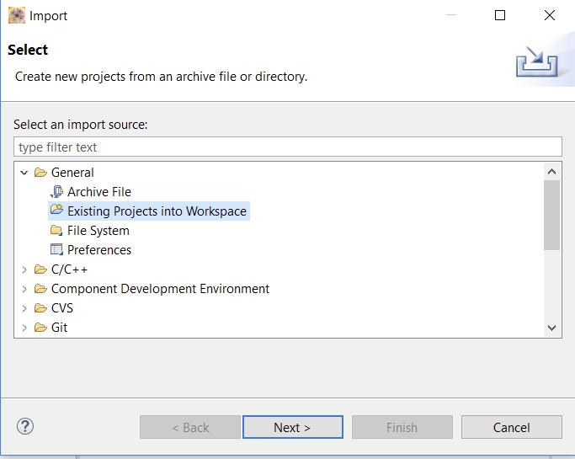

6. The “Import” window is opened.

Click on “Browse” button and locate the chosen project.

“MCRSP_BLDC_V1.3.0\build_ref_solutions\frdmkv31f\kds “, confirmed by clicking the “OK” button.

(For example, the chosen project could be at

C:\NXP\MCRSP_BLDC_V1.3.0\build_ref_solutions\frdmkv31f\kds)

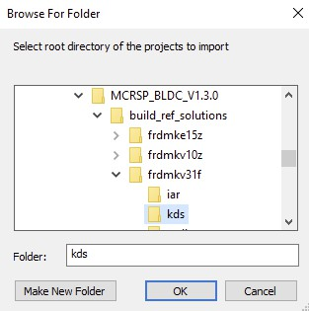

7. Last step is the confirmation of project by clicking on “Finish” button.

+

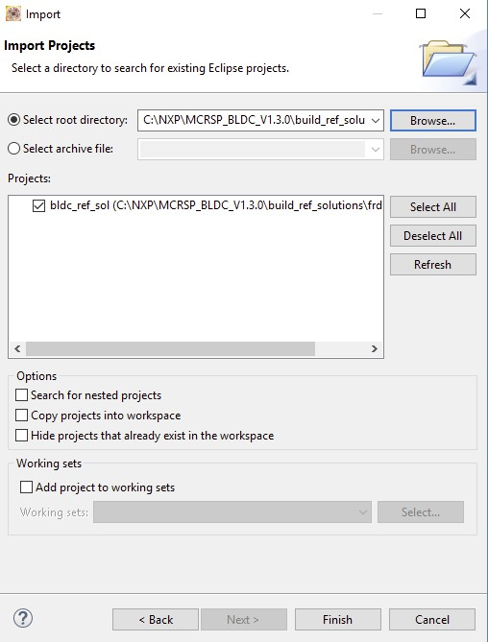

8. Click on Build Icon. (MAKE SURE THAT THE PEMICRO DRIVERS IS   
 INSTALLED OTHERWISE INSTALL IT FROM COURSE WEBSITE)

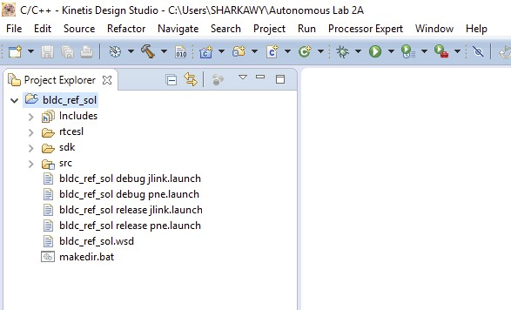

9. Now connect your board, with shield mounted on it, if not already connected.

10.Click on Debug configuration. (the drop-down option by the icon )

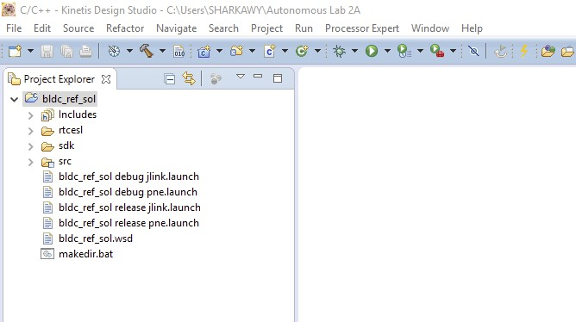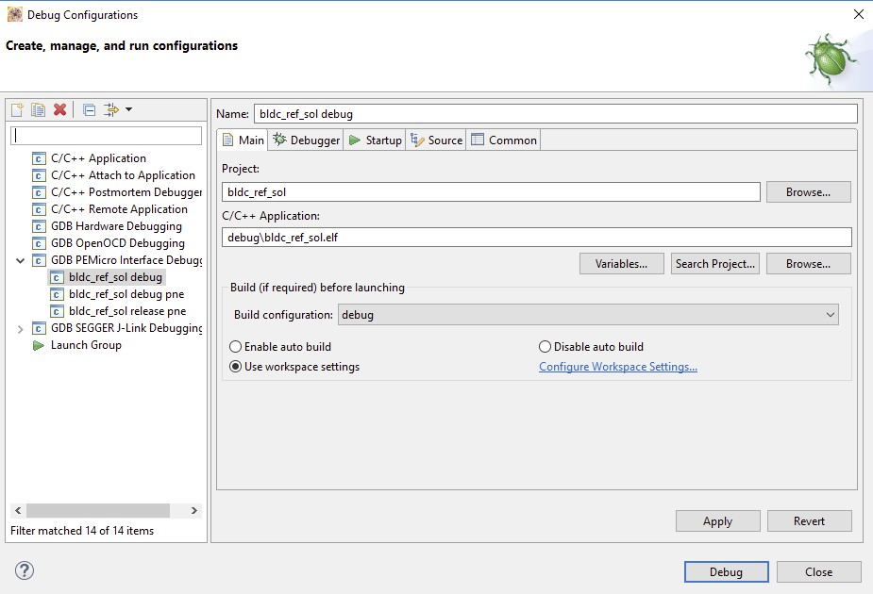

11. Click on “GDB PEMicro Interface Debugging” to start a new one   
 (instead of the ones that already existed).

12. Select debugger and make sure the interface reads “OpenSDA Embedded   
 Debug - USB port” and port reads your device. Select device as   
 KV31F128M10.

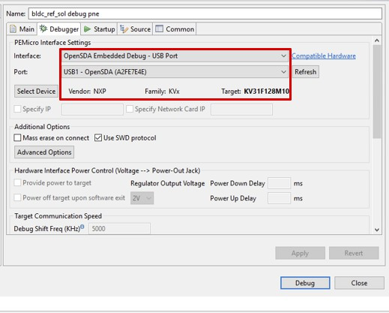

13.Click on Debug then yes on the following pop-up.

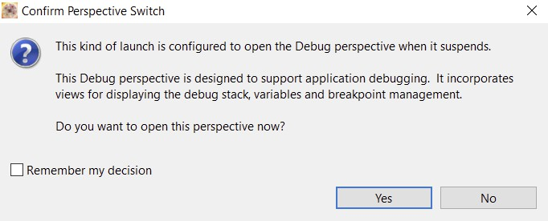

14.Make sure the external supply is connected and the red LED is stable.

15.Click on Resume or press F8 on the keyboard.

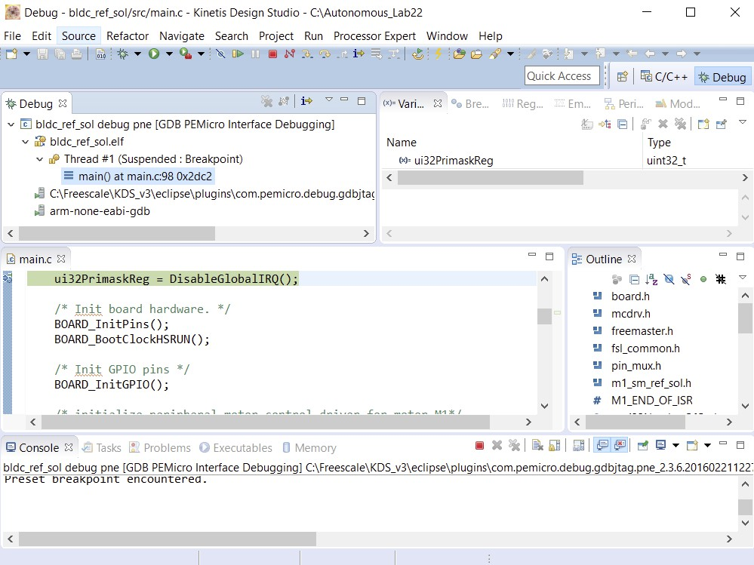

6. User Interface

The application contains demo application mode for demonstration purposes of motor rotating and can be operated either using the user button or with using a FreeMASTER Tool.

• User Button on Freedom development boards (SW2 for KV31F)

• Remote control using FreeMASTER

6.1. Button Control

Pressing the SW2 button the demonstration mode is switched on (or demonstration mode is switched off if it is on).

6.2. Remote control using FreeMASTER

Remote operation can be provided by FreeMASTER software via the USB interface. FreeMASTER 3.1 is required to guarantee the correct operation of application. Follow the below steps to remote control via FreeMaster.

1. Open the FreeMaster software.
2. Click on Open Icon from the Main toolbar. Alternatively, Select File -> Open Project.
3. Navigate to the MCRSP_BLDC installation location.
4. Open MCRSP_BLDC\freemaster\ bldc_ref_sol.pmp
5. This should open the project with bldc_ref_sol.

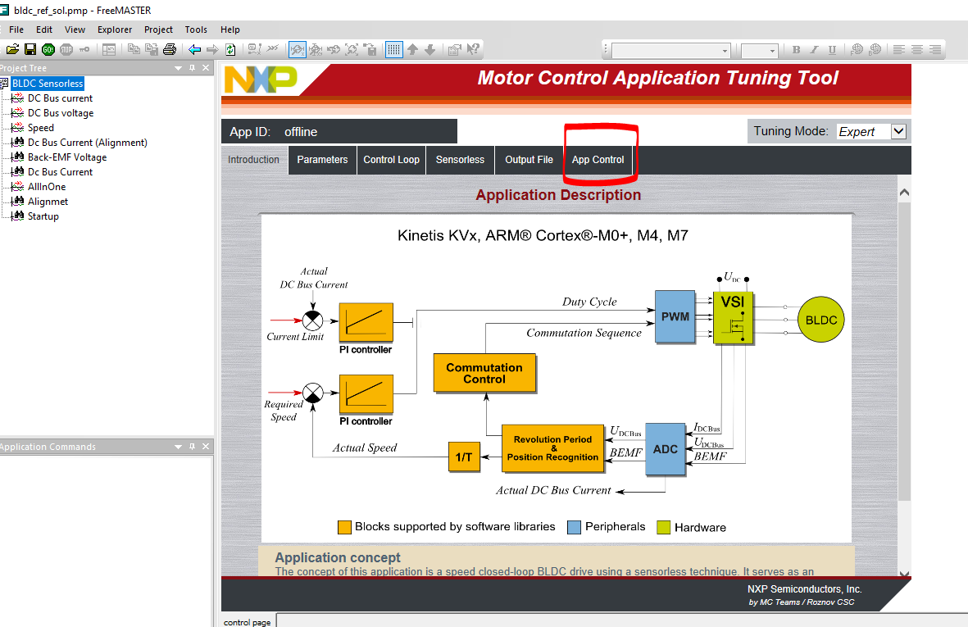

1. Open App Control in the application (Marked in the above image). Control Page details are in section 6.2.1.
2. It should say “Communication Error”. We will establish communication in the following steps.

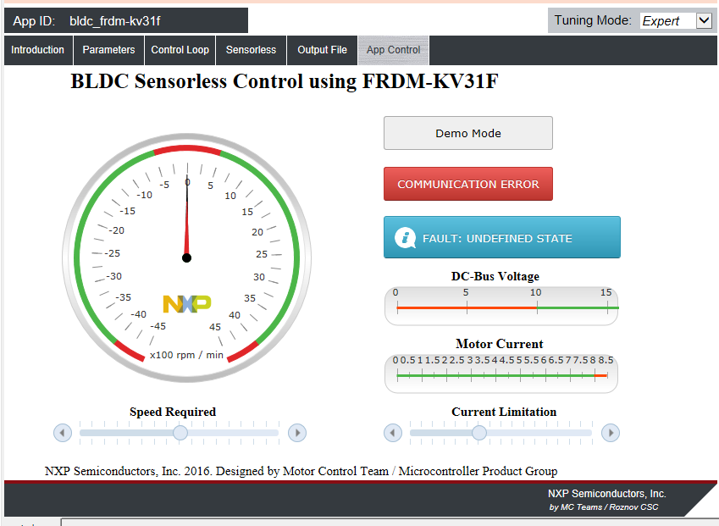

1. In Free master Select Tools > Connection Wizard > Next. Select “use direct connection to onboard USB port”. Select OpenSDA COM port and 115200 baud rates > Next > Finish.

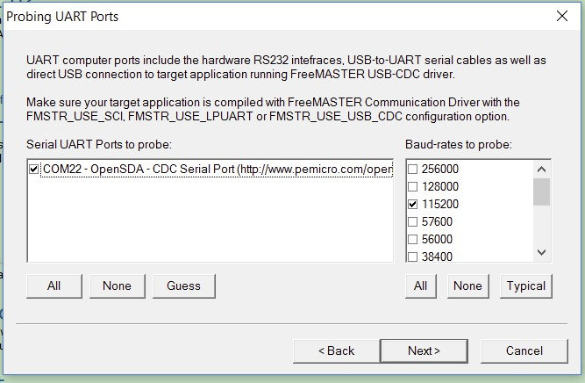

1. Now the connection should be established, and you can control the BLDC motor with your FreeMASTER App.

6.2.1. Control Page

After launching the application and performing all necessary settings BLDC motor can be controlled from FreeMASTER control page.

FreeMASTER control page contains:

• Speed gauge - showing actual and required speed

• Speed slider - to setup the required speed

• DC bus voltage gauge - showing actual dc bus voltage

• DC bus current gauge - showing actual dc bus current

• DC bus current limitation slider - to setup dc bus current limit

• Demo mode button - To turn on/off demonstration mode

• STOP Button - to stop the whole application

Application State Notification - showing actual application state and faults.

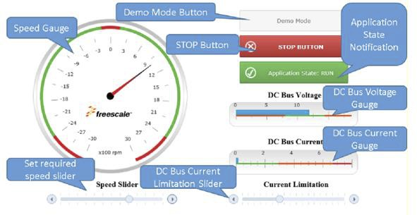

6.3. Controlling BLDC Motor

Follow the following steps to be able to control BLDC motor:

You can now control the motor by clicking on “BLDC Sensor less” on the left side in the project tree then “app control” and run.

You can control the speed by varying the Speed slider and current by current slider.

On the left side in the project tree, click on the DC Bus Current, speed, etc. to observe the corresponding plots:

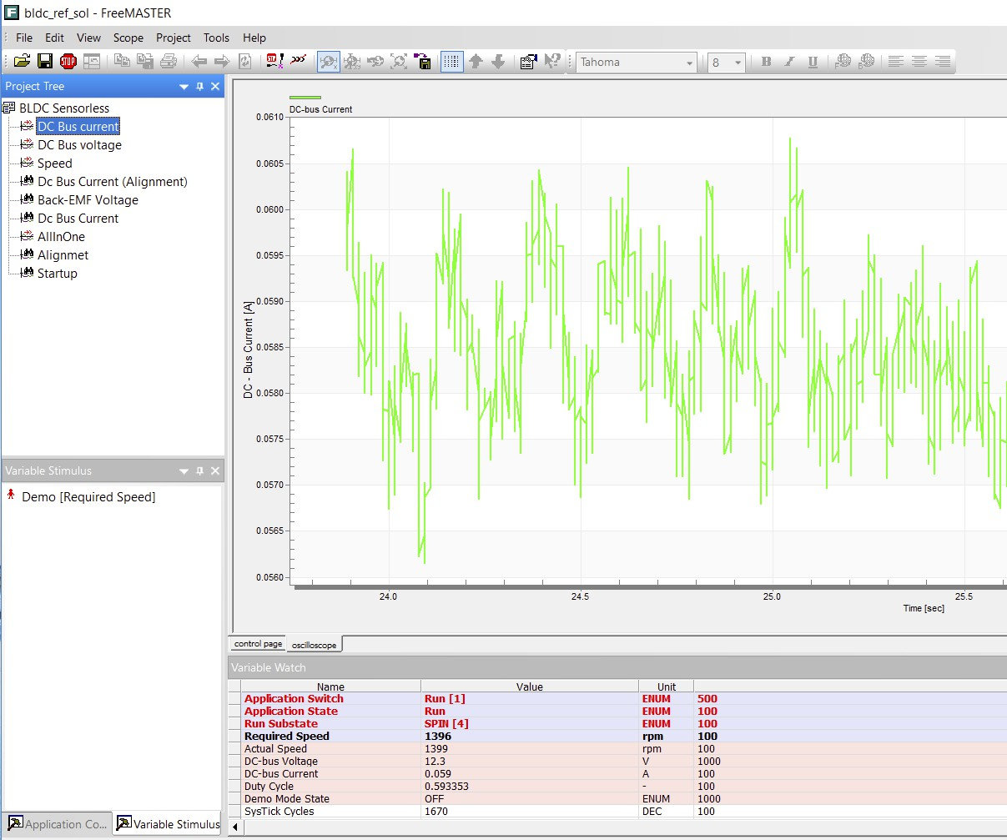

7. Summary

Basic Instructions:

• To start the motor run, use the Speed Slider to setup required speed.

• In case of a fault is indicated, click on “CLEAR FAULT” button to clear fault.

• Click on Demo Mode button to turn on/off demonstration mode

• Click on Stop button to stop the motor.

7.1. How to Run motor

1. Assemble your hardware.

2. Download the correct project into your target via OpenSDA debug interface.

3. Open the FreeMASTER project, establish the communication between   
 MCU and PC.

4. Set up the required speed of the motor on the speed slider on the FreeMASTER   
 control page.

7.2. How to Stop motor

1. Click on Stop button on FreeMASTER control page.

2. Require zero speed with using speed slider.

3. In emergency cases, turn off power supply.

7.3. How to Clear the fault

To clear the fault just click on “CLEAR FAULT” button control page when   
occurs.

7.4. How to Turn on Demonstration mode

1. If you use FreeMASTER control page, just click on Demo Button.

2. If you don’t use FreeMASTER control page push SW2 on your development   
 board to turn demonstration mode on/off.

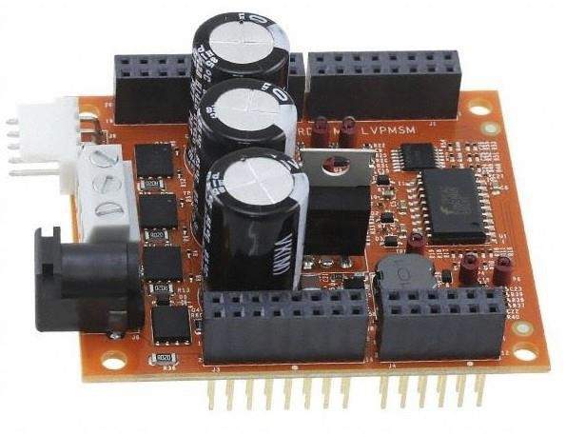

Part II: PERMANENT MAGNET SYNCHRONOUS   
 MOTOR (PMSM) Sensorless Appication

Please review Part I before starting Part II.

Note that the FRDM-MC-LVBLDC shield is replaced by the FRDM-MC-LVPMSM shield.

and the software MCRSP_PMSM_V1.2 is used instead of MCRSP_BLDC_V1.3.

1. MCRSP_PMSM Package

MCRSP_BLDC package includes source codes for development board. The package folder can be found at your course website.

2. FRDM-MC-LVPMSM

The FRDM-MC-LVPMSM low voltage evaluation board, in a shield form factor, effectively turns a Freedom development board platform into a complete motor control reference design, compatible with existing Freedom development   
platform FRDM-KV31F.

FRDM-MC-LVPMSM board does not require any hardware configuration or jumpers setting. It contains no jumpers.

1. Locate the “MCRSP PMSM V1.2” executable file at the course website and   
 install it. For example, the folder will be at C:\NXP\ MCRSP_PMSM_V1.2.

2. Run KDS IDE



3. Select workspace: choose default or specify new one then click OK.

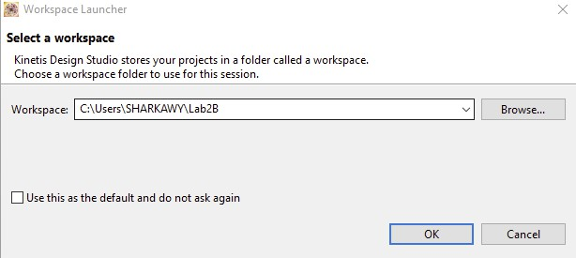

4. Click on “File” menu in left-top corner of the IDE then chose “Import” from   
 “File” list menu.

5. The “Import” window is opened. Locate “Existing Projects into Workspace”   
 in “General” folder then click the “Next” button.



6. The “Import” window is opened.

Click on “Browse” button and locate the chosen project

“MCRSP_PMSM_V1.2\build_ref_solutions\frdmkv31f\kds “, confirmed by clicking the “OK” button.

(For example, the chosen project could be at for example,

C:\NXP\MCRSP_PMSM_V1.1.2\build_ref_solutions\frdmkv31f\kds)

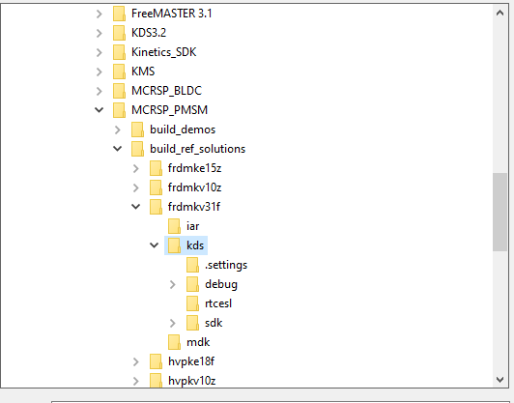

7. Last step is the confirmation of project by clicking on “Finish” button.

8. Build the project by clicking on the Build Icon (MAKE SURE THAT THE

PEMICRO DRIVERS IS INSTALLED OTHERWISE INSTALL IT FROM COURSE WEBSITE)

9. Mount FRDM-MC-LVPMSM shield on top of KV31F. There exists only one   
 possible option.

10. Connect the motor three phase wires into the screw terminals on the board (do   
 not connect encoders as we are performing sensor less operation).

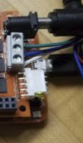

11. Power the shield using the 24V adapter (you should see no blinking LED on the board).

12. Connect the FRDM KV31F (in OpenSDA Debug mode) using Micro USB cable.

13. After a successful build, the next step would be debugging configuration.   
 Select Debug Configuration in the dropdown menu of debug.

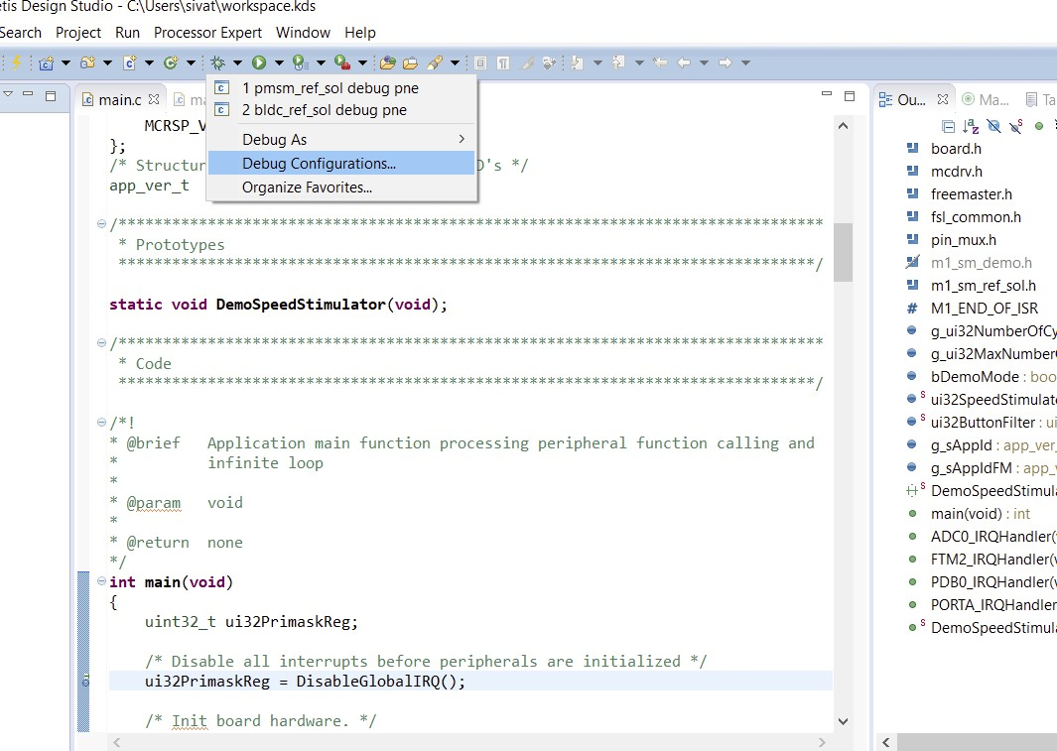

14. Click on “GDB PEMicro Interface Debugging” to start a new one (instead   
 of the ones that already existed).

Make sure that the interface is “OpenSDA Embedded Debug - USB Port” and the port is “USB1-OpenSDA”. Select device as KV31F128M10.

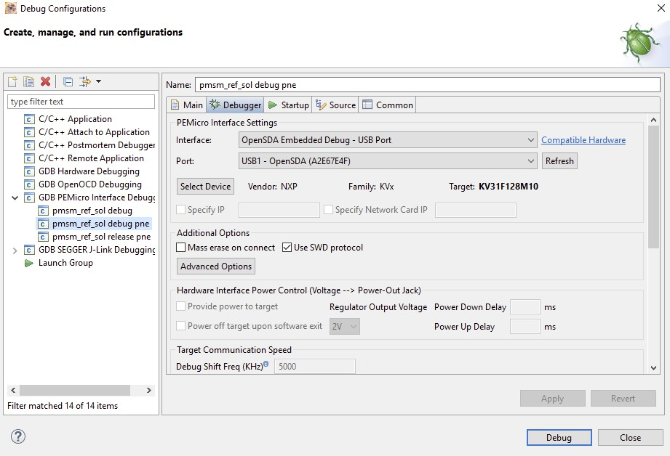

15. Click on “Debug”. Debug perspective will be displayed.



16. Click on Resume button or press F8 on keyboard. (The board will run the   
 code).

You can also run the default demo, by hitting SW2 (LED turns Green).

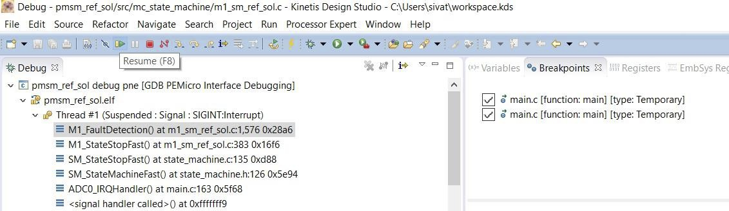

17. Open FreeMASTER software that is previously installed.

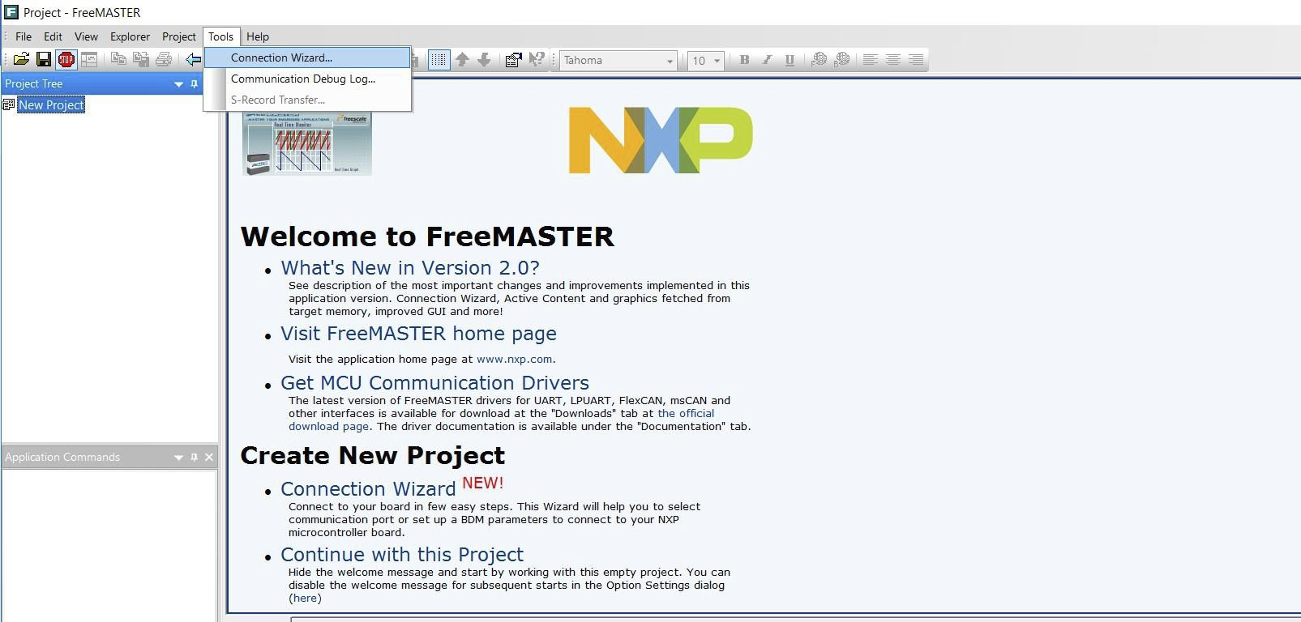

18. Select Tools > Connection Wizard > Next.

19. Select “use direct connection to onboard USB port”.

20. Select open SDA COM port and 115200 baud rate > Next > Finish.

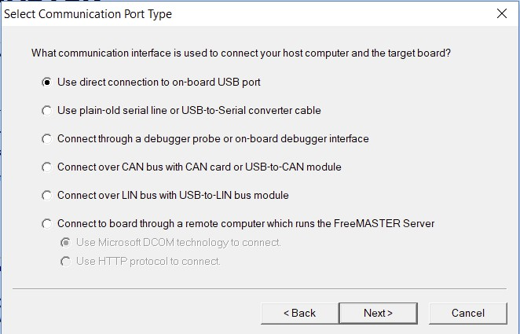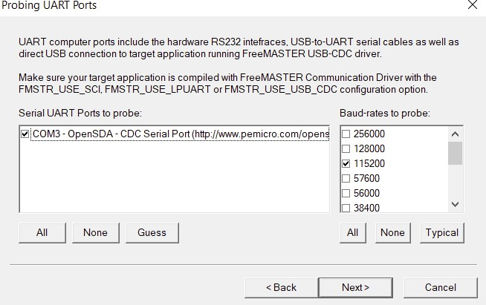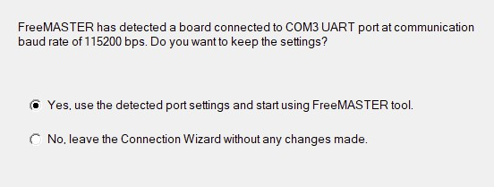

20. Click on file > open project > navigate to

C:\NXP\MCRSP_PMSM_V1.2.0\freemaster -> open “pmsm_ref_sol”.

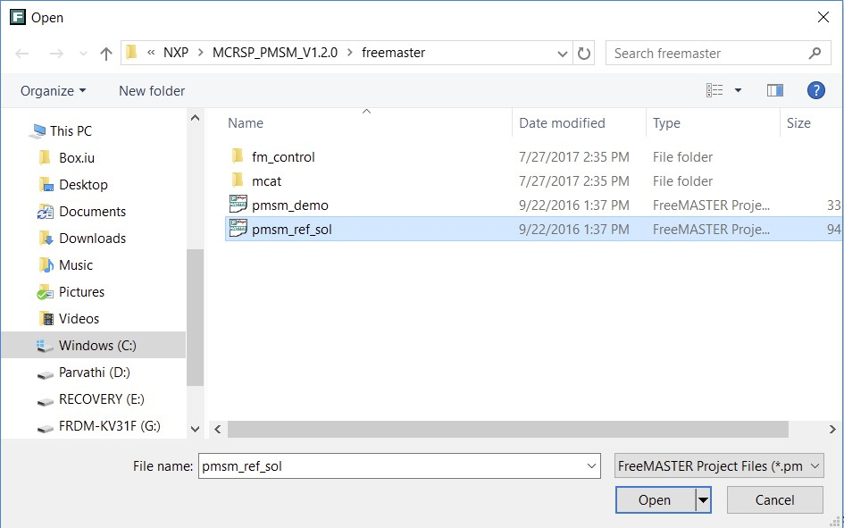

21. In the Project Tree, select PMSM FOC Sensor less -> App Control

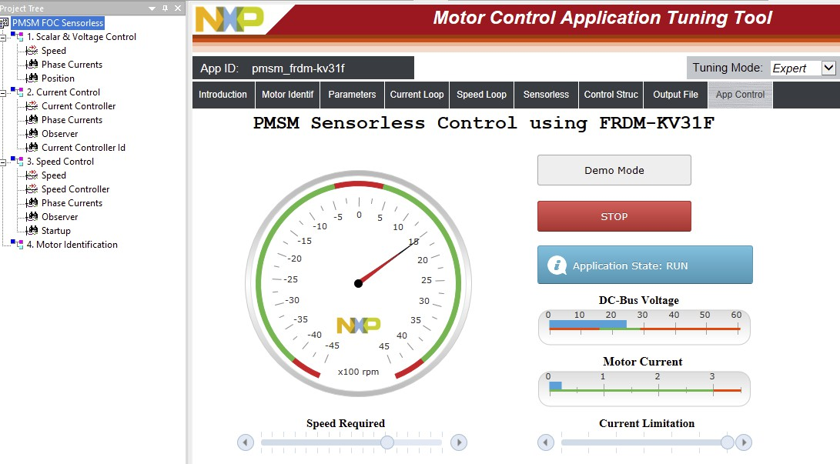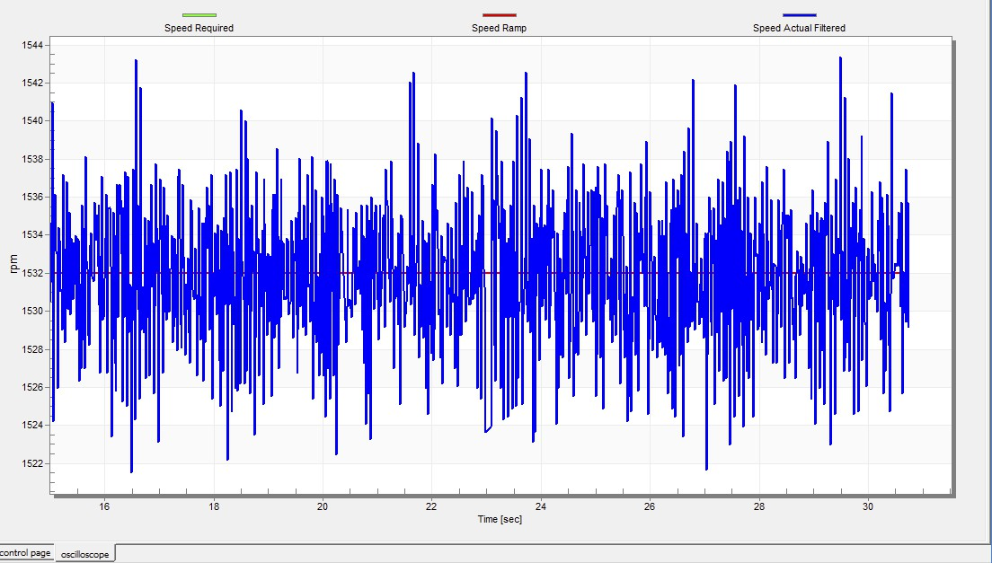

22. The motor can be set in a run state by clicking on RUN and setting   
 required speed. Make sure that the Bus Voltage is 24 V. Select   
 “Speed” in the project tree on the left to plot the speed.

23. Observe the speed, phase current plots for the target speed and

record them as shown below.

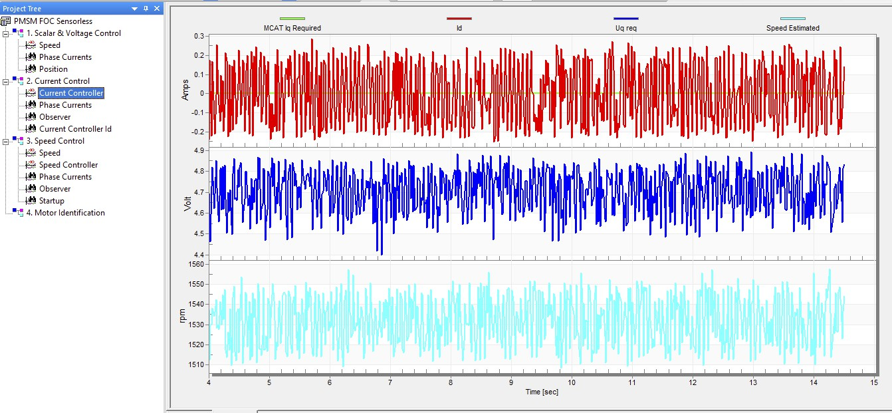

Please review.

"Lab 2_Appendix_Motor_Control_Application_Tuning_Tool"

at the course website for more information about the MCAT tool tabs. PMSM will be discussed later in the course.